Power BI Lab Report
Introduction to Power BI
Tamar Tutisani

4.1 Load Data
Connected to the local SQL Server via SQL Server Database connector, provided the server. Selected FactInternetSales and used Select Related Tables to automatically pull in all related dimension tables, then clicked Transform Data to open Power Query Editor.
4.2 Full Customer Name (DimCustomer)
The FirstName and LastName columns were duplicated and merged using Space as separator, creating a Full Name column. Screenshot shows the result with correctly merged names (e.g., "Jon Yang", "Eugene Huang") and the Applied Steps panel confirming the Inserted Merged Column step.
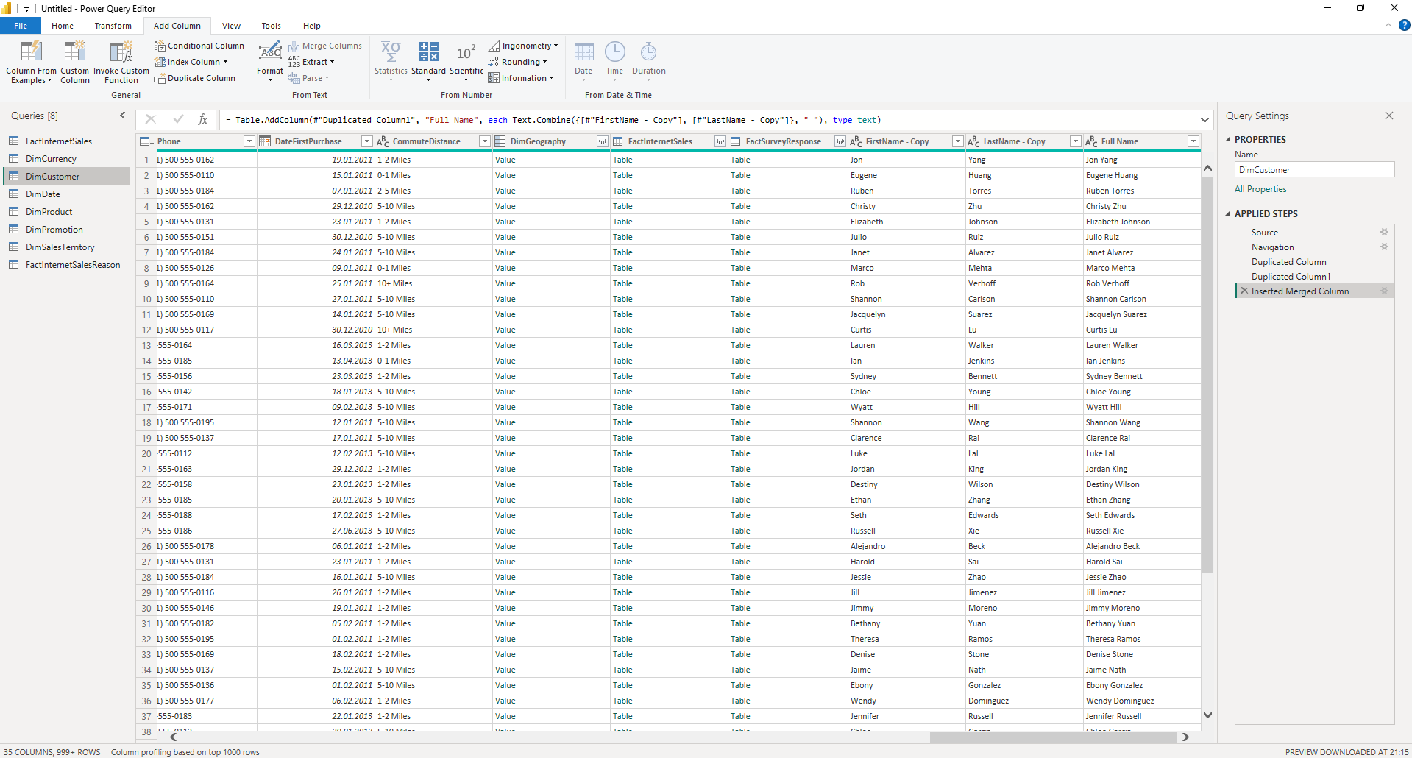

4.2 DiscountPct Column Type (DimPromotion)
The DiscountPct column type was changed to Percentage. Screenshot shows values now displaying in percentage format (0,00%, 2,00%, 5,00%, etc.) with the Changed Type step visible in Applied Steps.
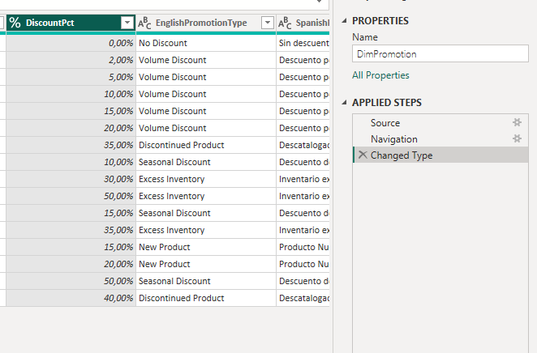

4.2 Promotion Campaign Length (DimPromotion)
Date Subtraction was applied on StartDate and EndDate columns to calculate campaign duration. Screenshot below shows the resulting Subtraction column with values in days (e.g., 1309, 1095, 46, 30) and the Inserted Date Subtraction step confirmed in Applied Steps.
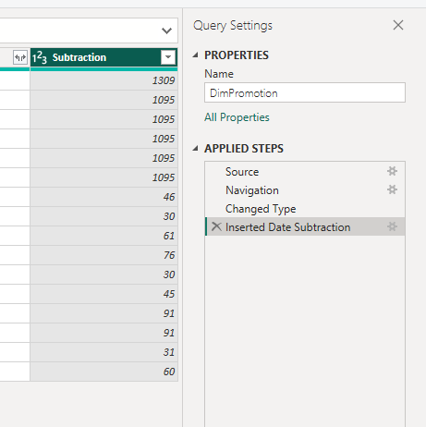
4.3 Adding New Tables
DimProductSubcategory and DimProductCategory were loaded additionally from the AdventureWorksDW2017 database. Both tables appear in the Queries panel on the left side of Power Query Editor.

4.4 Data Profiling
Column Quality, Column Distribution, and Column Profile were enabled from the View tab. Screenshots show DimProductSubcategory and DimProductCategory tables respectively, both showing 100% Valid, 0% Error, 0% Empty across all columns, with distribution bars visible under each column header.
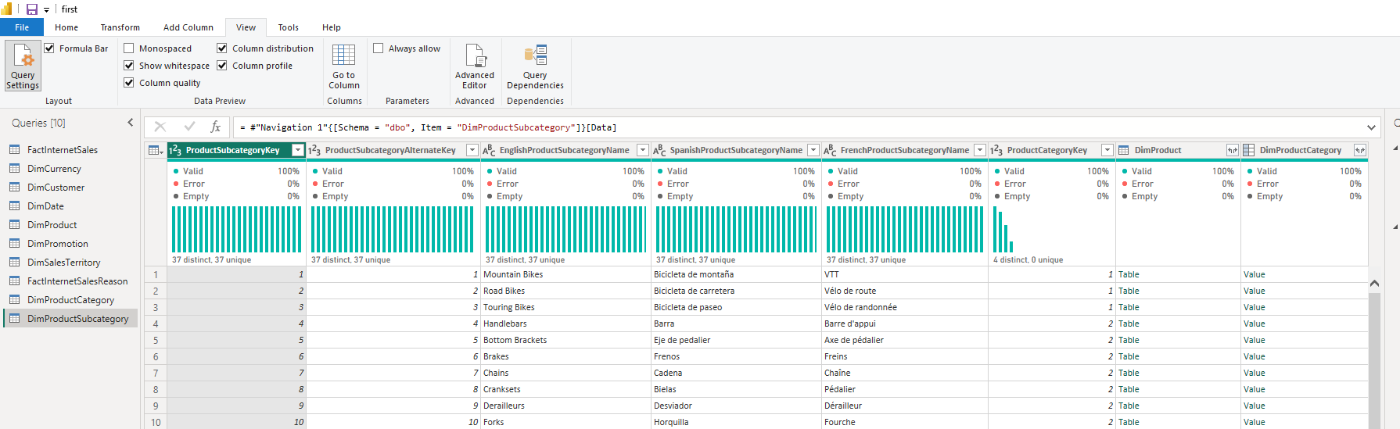
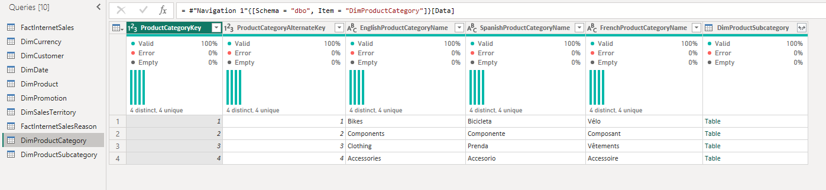
4.5 SalesByYearsNPrice Table
A reference of FactInternetSales was created, renamed to SalesByYearsNPrice, and trimmed to four columns: Order Year, OrderQuantity, DiscountAmount, SalesAmount. Screenshot confirms the table structure with the Removed Other Columns step in Applied Steps. 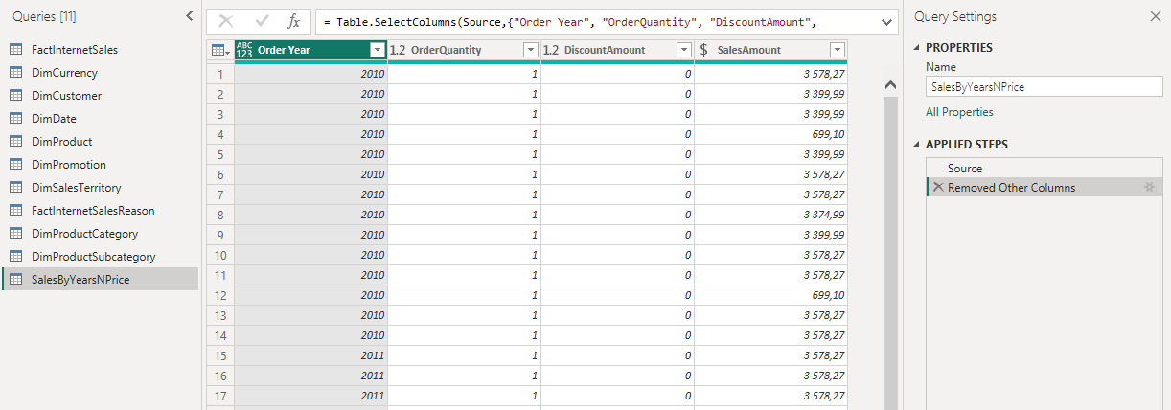
After applying Pivot Column on Order Year with SalesAmount as the value, Screenshot below shows years (2010-2014) becoming separate columns with aggregated sales totals, e.g., 2013 totaling 16,351,550.34.
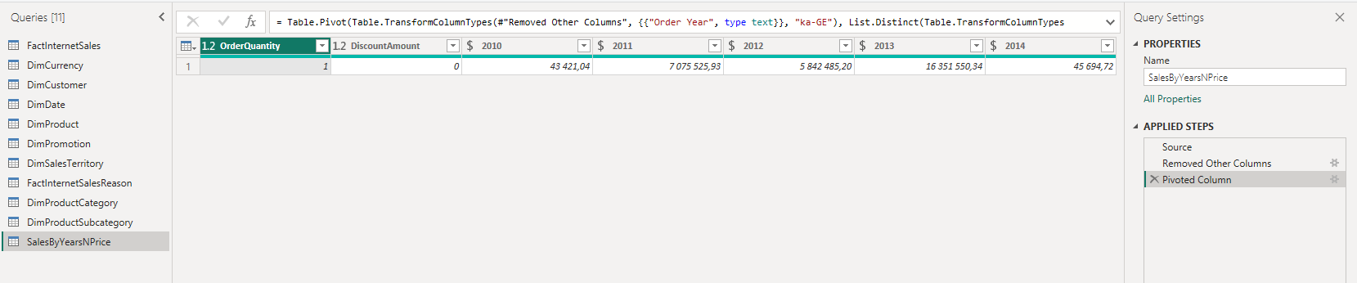
4.6 Table Joining (SalesByCountry)
A new table SalesByCountry was created by referencing FactInternetSales, keeping only four columns: ProductKey, Order Year, SalesAmount, and SalesTerritoryKey.
To enrich the data with territory and product category information, a multi-step table joining process was executed using Merge Queries with a Left Outer join type:
- Territory Join: Merged with DimSalesTerritory using SalesTerritoryKey, then expanded to include the SalesTerritoryCountry column.
- Product Subcategory Key Join: Merged with DimProduct using ProductKey, expanding to retrieve ProductSubcategoryKey.
- Product Category Key Join: Merged with DimProductSubcategory using ProductSubcategoryKey, expanding to retrieve ProductCategoryKey.
- Product Category Name Join: Merged with DimProductCategory using ProductCategoryKey, expanding to extract the final EnglishProductCategoryName.
The Applied Steps panel confirms all merge and expand operations completed successfully.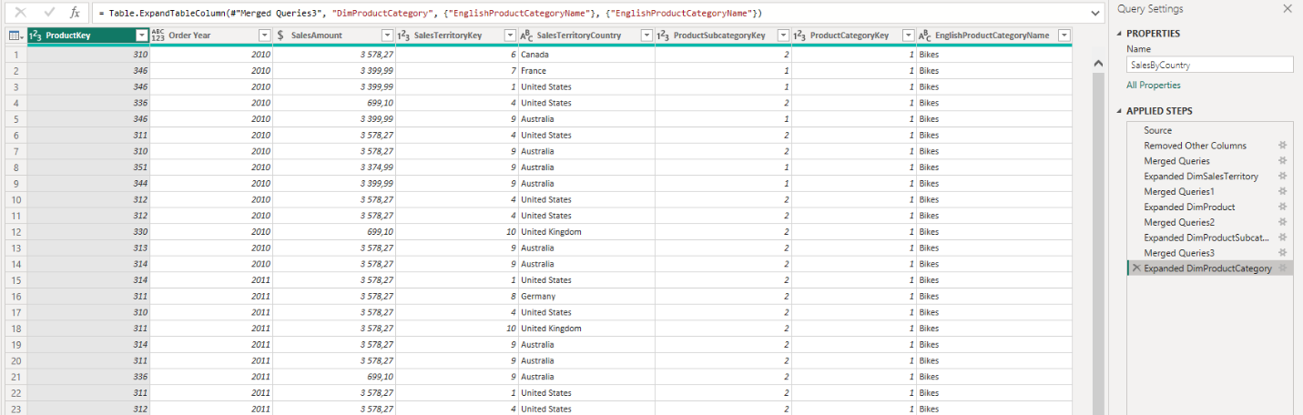
4.7 Grouping Data
The Group By feature was opened from the Transform tab using Advanced mode to aggregate multiple columns. Order Year, SalesTerritoryCountry, and EnglishProductCategoryName were set as the grouping columns. A new column named Sales was created using the Sum operation on the SalesAmount column. Finally, the table was sorted ascending by Order Year.
The resulting table effectively summarizes sales performance by year, country, and product category. The Grouped Rows step is visible in the Applied Steps panel.
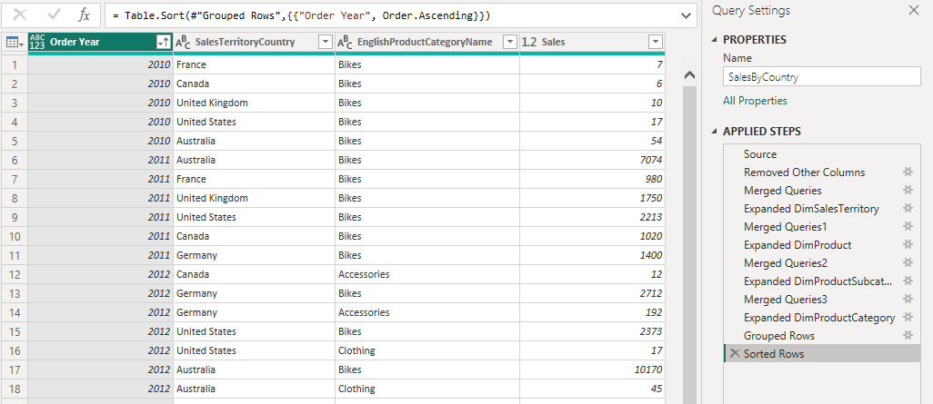
4.9 Import vs. DirectQuery
Import mode loads a full copy of the data from the source into Power BI's internal memory when you click "Close & Apply". All report visuals then query this cached copy, which makes interactions fast. The downside is that the data doesn't update automatically, you have to manually refresh or schedule a refresh to pick up changes from the source. This mode works best when the dataset is reasonably sized and doesn't need to be real-time.
DirectQuery mode doesn't copy any data. Instead, every time you interact with a visual, Power BI sends a live query to the source database and returns the result. This means the data is always current, but it also means performance depends entirely on how fast the database responds. If the source is slow, the report will feel slow. DirectQuery also has limitations, some Power BI features like certain DAX functions and calculated columns aren't available.

In practice, Import is the better choice for most reports. DirectQuery is useful when the data changes constantly and you need real-time accuracy, or when the dataset is too large to import.

